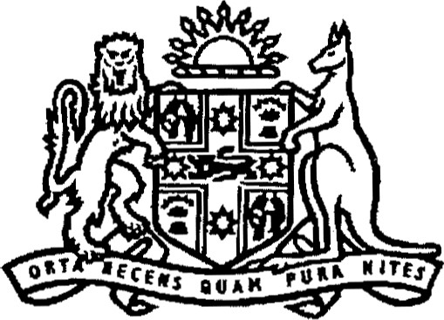
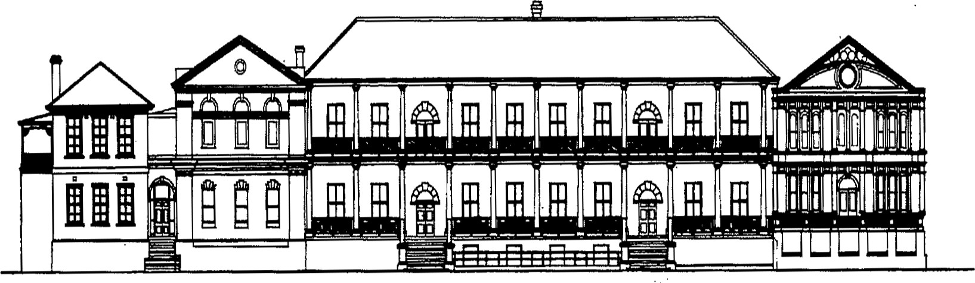
Legislative Assembly

PARLIAMENTAR Y DEBA TES (HANSARD)
GETTING IT TOGETHER
Private Member's Statement
Greg Warren MP
Memberfor Campbelltown
Thursday 25 February 2016
FIFTY-SIXTH PARLIAMENT of NEW SOUTH WALES
GETTING IT TOGETHER
Mr GREG WARREN (Campbelltown) [6.22p.m.]: In January this year I had the privilege of attending the Getting It Together Aboriginal services networking event with the Hon. Sophie Cotsis, member of the Legislative Council, shadow Minister for Women, shadow Minister for Ageing, shadow Minister for Disability Services, and shadow Minister for Multiculturalism. Getting It Together, which was organised by Marilyn Fogarty from the Macarthur Gateway Resource Services and members of the Tharawal Aboriginal Corporation, was held at Bradbury Oval in Campbelltown. The aim of the event is to strengthen connections between Macarthur Gateway Resource Services clients and partner organisations, by acknowledging specialist Aboriginal services within south-western Sydney, who are all working together to close the gap. This is an important issue for all of us in this place.
The Getting It Together event hosted close to 50 stalls, consisting of service providers, community groups and support organisations. Information addressing service needs such as homelessness, domestic violence, women and children's specialty health services, legal resources and disability support was available for all in attendance. Organisations such as the Benevolent Society, Youth Off The Streets and the Tharawal Local Aboriginal Land Council Men's Shed helped celebrate the diversity and rich cultures of the Tharawal Aboriginal people in Campbelltown and across New South Wales and Australia.
Above all, Getting It Together provided the opportunity for relationships to be developed within the community and for faces to be put to the very important services available to help local families. Macarthur Gateway Resource Services promoted not only social services but also community groups, including the men's shed, women's social groups and many more. As organiser Ms Fogarty said:
It is not just about letting the community know that these services exist and offer assistance, but also making people feel comfortable with contacting them.
By introducing the community to the services available in a comfortable and social environment, where service providers and constituents are learning about one another and connecting on a personal level, community members are more likely to feel safe and ask for a helping hand in times of need. Further, the contribution of Getting It Together to the development of a culturally sensitive system of service management is invaluable. I note that this event was the first of its kind and a positive step in reducing the gap for our community. I think it could be taken to many other communities throughout New South Wales.
Stallholders were able to make visitors feel welcome and valued by discussing and witnessing the cultural practices of Macarthur's Indigenous clientele. I acknowledge Uncle Ivan Wellington for his wonderful welcome to country and smoking ceremony. I also acknowledge Aunty Joyce, the many other Aboriginal leaders present and my friends in the Campbelltoyvn community- The celebration of heritage and Aboriginal culture was showcased by Australian Idol winner Casey Donovan's live performance, as well as the Koomurri Dancers' traditional performances. Joshua Bell, a good local guy, was also there. He is from Airds and is a strong community leader in both the Aboriginal community and the non-Indigenous community.
Kids' activities, live enfertainment, arts and crafts workshops, interactive games, sporting activities and food stalls encouraged an inclusive environment for all local organisations. Getting It Together was equally as important for service providers to attend, as they too learnt about how they can accommodate and facilitate the needs of Aboriginal people and other people throughout south-western Sydney, particularly in the Macarthur area and in Campbelltown. I shared the day with my fellow community members, discussing the ups and downs of everyday life, swapping stories and life experiences, making new connections and friendships, and learning about how we as a wider community can help not only struggling Aboriginal people but also struggling people from all walks of life. It made me proud to be the member for Campbelltown. Events like these prove that as a community we are united and have an inclusive and engaging attitude. We will not let a fellow brother or sister slip through the cracks without adequate social services and community support.
I commend Marilyn Fogarty of Macarthur Gateway Resource Services and members of the Tharawal Aboriginal Corporation for helping establish a management system that develops a culturally appropriate case management framework to guide partner agencies to assist both Indigenous and non-Indigenous people, particularly women and children who are experiencing family and domestic violence, homelessness, drug and alcohol dependencies or facing other day-to-day challenges. It is essential that this fantastic event and others like it continue as a positive step forward. I hope that communities all over New South Wales follow in the footsteps of the Getting It Together model, empowering the Aboriginal community to turn challenges into opportunities.

